Project V1

Blackjack

CSC – 46090

Name: Anthony Vantino

Date: 07/21/15

**Introduction**

Blackjack

**Game Objective**

Blackjack is played against the casino so the main objective is to have a total hand value that exceeds the total hand value of the dealer without going over a total point value of 21.

A traditional 52 cards deck is used (or several decks) and each card has a point value attached to it. Aces count as 1 or 11, Face cards (King, Queen and Jack) count as 10 and all other cards keep the value that is printed on them.

**How to Play**

The dealer deals each player two cards facing up. The dealer also gets two cards but only one is facing up and the other is facing down (known as the hole card). Players are allowed to draw additional cards to the total hand value of 21.

Once a player drew a card that takes his total hand value above 21 they bust out of the game. Either the dealer or player can win the hand with low valued hands in situations when one or the other busted out of the game.

**Summary**

Project size: 186 Lines

Number of Variables: 11

The Number of methods: 7

This project includes many of the concepts that we learned throughout the Summer Semester. I used Gaddis 8th Edition for reference points. This project has much room to be expanded and improved on due to the short time constraints with the summer class schedule, with arrays and pointers, etc. being taught at this moment I can see version 2 being much more fleshed out and easier to use.

It took around a week. I tried my best to not use arrays until I was completely comfortable with the new way of doing things. Once I find the perfect way to utilize the array function the project can be expanded greatly, especially in the deck and dealing functions I am using currently. Towards the end of the project I came into many annoying bugs that can be fleshed out over time and a lot of hard work with probably re-writing some of the functions used. I used other Blackjack C++ games found on the internet as examples and templates as I tried to piece together the best possible game.

**Description**

The main point that I programmed this project is dealing, and how the cards are dealt to the player and the House as the game progresses.

**Flowchart**

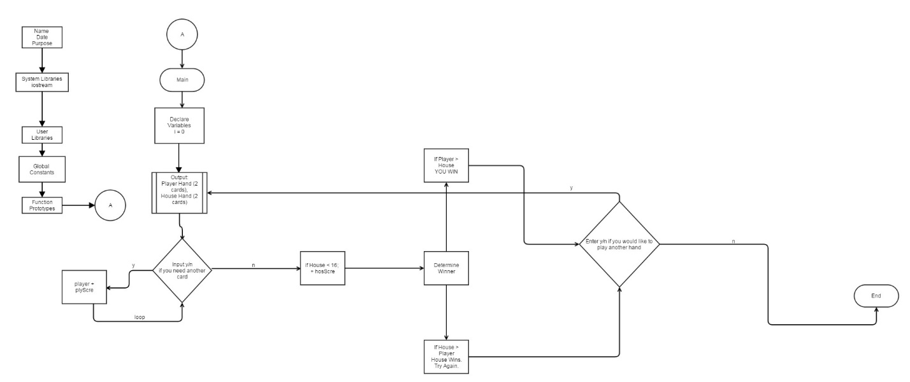**Pseudo Code**

*Initialize*

*If the start button is pressed*

*Display greeting message that the round as begun*

*Display player hand and the house hand*

*If player needs another card*

*Get and output another card*

*Else*

*Begin House turn*

*Output cards until house is greater than 16*

*If Player Hand is greater than House Hand*

*Output Congratulations string*

*Else*

*Output Try Again string*

*If player inputs to play again*

*Loop*

*Else*

*Exit Program*

**Major Variables**



**C++ Constructs**



**Reference**

1. Gaddis 8th Edition
2. [www.cplusplus.com](http://www.cplusplus.com) (forum for helping people with C++ coding)

**Program**

//System Libraries

#include <iostream>

#include <cstdlib>

#include <ctime>

#include <string>

using namespace std;

//Global Constants

//Function Prototypes

void blckJck(void);

void winner(int, int);

int deal(int);

void hit(int&);

int random(int, int);

void houseHt(int&);

//Execution begins here

int main(int argv,char *argc[]){

srand(time(NULL));

//Declare Variables

int i = 0; //Counter

//Play Blackjack

char keepPly = 'n'; //loop control variable

do{

blckJck();

cout << "Do you want to play another hand (y/n)?"<<endl;

cin >> keepPly;

cin.ignore();

}while(keepPly == 'Y' || keepPly == 'y');

return 0;

}

/****************************************************

* BlackJack *

****************************************************

* Purpose: To play blackjack

* Input:

* hit -> draw another card

* stand -> do not take another card

* Output:

* Hit -> hit player hand

* houseHt -> Hit house hand if below 16

* Winner -> Winner of the round, who has the bigger hand.

*/

void blckJck (void){

//Deal Cards

cout<<"\n\n\n\n\nStart of Round: "<<endl<<endl;

cout<<"You were dealt."<<endl;

int player = deal(1) + deal(1);

cout<<" = "<<player<<endl<<endl;

cout<<"The House was dealt."<<endl;

int house = deal(1) + deal(1);

cout<<" = "<<house<<endl<<endl;

//Ask Player if he would like to hit

hit(player);

cout<<endl;

//If House needs to hit or not

houseHt(house);

cout<<endl;

//show who won....

winner(player, house);

}

/****************************************************

* Winner *

****************************************************

* Purpose: Display winner

* Input:

*

* Output:

* Winner -> Winner of the round, who has the bigger hand.

*/

void winner(int plyScre, int hosScre){

//Compare the scores to see who won

if((plyScre > hosScre) && (plyScre <= 21)){

cout<<"You have the bigger hand. You Win!"<<endl<<endl;

} else if(hosScre == plyScre){

cout<<"You and the House Pushed. Try Again."<<endl<<endl;

}else if(hosScre > plyScre && hosScre <= 21){

cout<<"House has the bigger hand. Try Again."<<endl<<endl;

}

}

/****************************************************

* BlackJack *

****************************************************

* Purpose: To play blackjack

* Input:

* hit -> draw another card

* stand -> do not take another card

* Output:

* Winner -> Winner of the round, who has the bigger hand.

*/

int deal(int numCrds){

//This function deals the cards

int totVal = 0;

int value = 0;

for (int i = 0; i <= numCrds; i++){

int cards = i;

while(cards--){

value = random(0,10);

cout<<value<<" ";

totVal += value;

}

}

return totVal;

}

/****************************************************

* houseHt *

****************************************************

* Purpose: To hit the house hand if needed

* Input:

*

* Output:

* house -> House Hand plus hosScre

*/

void houseHt(int &hosScre){

int house = hosScre;

if (hosScre < 16){

house = hosScre + deal(1);

cout<<"The House takes a card "<<endl<<endl;

};

}

/****************************************************

* Hit *

****************************************************

* Purpose: Add onto hand previously dealt

* Input:

* wantCrd -> yes or no if player needs a card

* Output:

* plyScre -> Add player hand with plyScre for hand total

*/

void hit(int &plyScre){

int cardCnt = 0;

char wantCrd = ('y','n');

int player = 0;

player = plyScre;

cout<<"Would you like another card? (y/n)"<<endl;

cin>>wantCrd;

cin.ignore();

while (wantCrd == 'Y' || wantCrd == 'y' && plyScre < 21){

if ((player > 0 ) && (player <= 21))

player += random(0,10);

cout<<"Your total is = " <<player<<endl<<endl;

cout<<"Do you want another card?"<<endl;

cin>>wantCrd;

cin.ignore();

//cout<<"You take a card. \n\nYour new total = "<<player + deal(1)<<endl<<endl;

if (wantCrd == 'Y' || wantCrd == 'y')

cout<<"You take a card. \n\nYour new total = "

<<player + deal(1)<<endl<<endl; // adds plyScre to hosCrd()

if (wantCrd == 'n' || wantCrd == 'N')

cout<<"You decide to stand. "<<endl<<endl;

}

}

/****************************************************

* random *

****************************************************

* Purpose: To generate random number depending on limit

* Input:

*

* Output:

* return -> random number generator with up limit to lower limit

*/

int random(int lowLim, int upLim){

//returns a random number within the given boundary

return 1 + rand() % (upLim - lowLim + 1);

}